

Médecins Sans Frontières
Operational Centre of Brussels
Rue de l’Arbre Bénit, 46
1050 Ixelles

Request for Proposal
_

DHIS2 App Development for Patient level Data
_

Operational Centre of Brussels of
Médecins Sans Frontières

June 18th, 2018

Authors: Yusuph K. Kulindwa
All information included in this RFP document are confidential and only for the intended recipient knowledge. No information included in this document or in discussions connected to it may be disclosed to any other party.

Purpose of document

This Request For Proposal is an invitation to select a group of companies to submit proposals for Médecins Sans Frontières Belgium (MSF B).
The intent is to Develop two applications on DHIS2 for MSF OCB located 46 rue de l’Arbre Bénit in 1050 Bruxelles.

Contact persons

All technical questions and inquiries regarding this RFP should be directed to:

focal point of contact:
Yusuph K. Kulindwa
e-Health Program Manager
e-mail : Yusuph.Kulindwa@brussels.msf.org
phone : + 32 (0)2 4747 564

Introduction

Médecins Sans Frontières

Médecins Sans Frontières (MSF) is a private international association that provides assistance to populations in distress, to victims of natural or man-made disasters and to victims of armed conflict. MSF observes neutrality and impartiality in the name of universal medical ethics and the right to humanitarian assistance and claims full and unhindered freedom in the exercise of its functions. Members undertake to respect their professional code of ethics and to maintain complete independence from all political, economic or religious powers.

MSF’s staff

Some 34,000 Médecins Sans Frontières (MSF) from all over the world provide assistance to people in crisis. They are doctors, nurses, midwives, surgeons, anaesthetists, epidemiologists, psychiatrists, psychologists, pharmacists, laboratory technicians, logistics experts, water and sanitation engineers, administrators and other support staff. More than 90 per cent are recruited in the countries where the programmes are, and they work with a small number of international staff.

MSF’s organization

MSF offices, units, operational centres and associations interconnect and work together in various ways, and are formally bound as one movement by a shared name, a shared commitment to the MSF Charter and principles, and shared membership of MSF International.

MSF International

MSF International is the association that safeguards the identity of the MSF Movement. Based in Geneva, MSF International's executive provides coordination, information and support to the MSF movement, and implements international projects and initiatives as requested. Regional MSF associations are members of MSF International.

MSF Associations

Currently, there are 24 associations. All are independent legal entities, and each elects its own board of directors and president. Most associations have an executive office that raises funds and recruits staff for MSF’s operations.
Section Switzerland, Section Austria,
Section Holland, Association East Africa, Section United Kingdom, Section Germany, Section Canada
Section Belgium, Branch Office South Africa, Branch Office Brazil, Section Sweden, Section Hong Kong, Section Norway, Section Luxembourg, Section Italy, Section Denmark,
Section Spain, Branch Office Argentina, Section Greece
Section France, Branch Office United Arab Emirates, Section Australia, Section USA, Section Japan.

Operational Centres

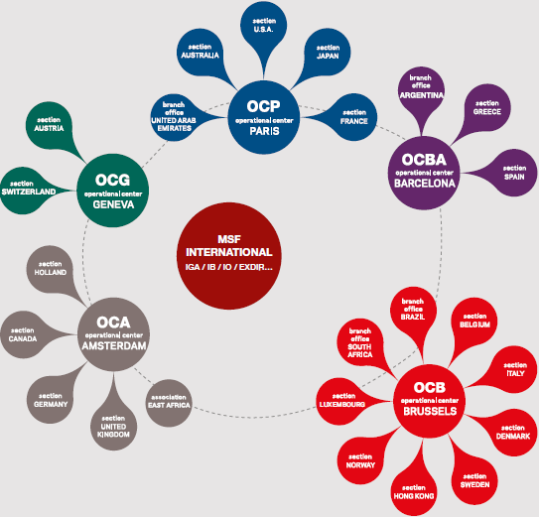
The associations are attached to five operational centres, which manage MSF’s humanitarian assistance programmes.
Operational Centre Geneva, Operational Centre Amsterdam, Operational Centre Barcelona, Operational Centre Brussels, Operational Centre Paris

Other Units

Other units, including supply centres and medical units, also support our activities.
Access Campaign, Epicentre, International Office, MSF Kenya Supply Unit, MSF Logistique, MSF Supply MSF, UK Office in Czech Republic, Office in India, Office in Ireland, Office in Mexico, Office in South Korea

MSF programs around the world

In 2013, MSF worked in 67 countries. MSF’s activities are a mix of direct, remote support and coordination support.

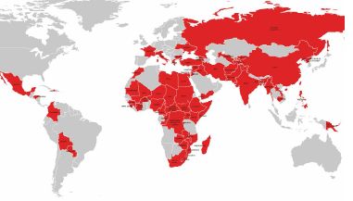
Afghanistan, Armenia, Bolivia, Bangladesh, Bulgaria, Burkina Faso, Burundi, Cameroon, Cambodia, China, Colombia, Central African Republic, Chad, Congo, Côte d’Ivoire, Democratic People’s Republic of Korea, Egypt, Democratic Republic of Congo, Ethiopia, France, Georgia, Greece, Guinea, Haiti, Honduras, Iran, Italy, LAOS, India, IRA Q, Jordan, Kyrgyzstan, Kenya, Lebanon, Lesotho, Libya, Madagascar, Malawi, Mali, Mauritania, Morocco, Mexico, Mozambique, Myanmar, Niger, Nigeria, Palestine, Papua New, Guinea, Pakistan, Philippines, Paraguay, Russian, Federation, South Africa, Somalia, South Sudan, Sudan, Swaziland, Syria, Sierra Leone, Tajikistan, Turkey, Ukraine, Uganda, Uzbekistan, Zambia, Zimbabwe, Yemen.

MSF OCB within the organization

MSF Operation Center Brussels – A Strategic partner
In 2013, Médecins Sans Frontières – Operational Centre Brussels (OCB) was involved in 32 missions with a medical component, comprising 78 projects. Overall, there were 1,806,530 consultations in the outpatient department (OPD) and 127,936 admissions to the inpatient department (IPD).

RFP Process

Selection Process

MSF B will perform an evaluation of the responses to this RFP. No selection of a solution will happen at this stage.

MSF B will select, based on the received information, suppliers in a short list for the next step (Request for Proposal).

After this RFP, MSF B reserves the right to enlarge or re-issue an RFP process.

RFP Planning

Below is defined the target selection process timeline:

- Issuance of Request For Proposal – 18th June, 2018
- Supplier’s confirmation of participation – 22nd June, 2018
- Supplier Questions related to RFP – 29th June, 2018
- RFP Answers by MSF – 3rd July, 2018
- Submission deadline of Proposals – 9th July, 2018
- MSF B Selection for the Vendor – 16th July, 2018

Confirmation of participation

Suppliers deciding to take part in this RFP are requested to send their written confirmation of participation by email to the contact persons by 22nd June 2018 at the latest.

Deadline to send response to RFP

The suppliers must send their responses and related documents by email to the contact persons: Yusuph K. Kulindwa (Yusuph.Kulindwa@brussels.msf.org) and Leila Lecapitaine (leila.lecapitaine@brussels.msf.org) by 9th July 2018 at the latest.

Supplier Response

The suppliers are requested to write as specific and concise answer to each of the questions in this RFP.
All questions and answers will be taken into account for the final supplier selection.

Response language

The responses and related documents must be submitted in English.

Modifications to RFP documents

MSF B reserves the right to revise or amend the terms and conditions of the RFP prior to the deadline for submission of supplier’s responses.

RFP Obligations & Cost

The issuing of the RFP does not imply any obligation for MSF B to buy any of the systems being presented.

MSF B reserves the right to stop the process at any time during the process.

All direct or indirect costs to the vendors linked to the response to this RFP as well as any subsequent negotiations will be borne by the vendor.

Confidentiality

This RFP, and any information disclosed or obtained during the RFP, must be treated as Confidential Information.

RFP Requirements

General requirements

Name of organisation
Address for all correspondence
Contact name and position
Telephone number
Fax number
Email address
Website address
Address of registered office
Number of employees that the organization has who can be involved with this project at a technical level
If the supplier is a member of a group of companies, please give the name and address of the parent company
If the supplier has partnerships, alliances, agreements with other companies, please give the name of the company

Financial Requirements

Name of Bank
(from which a financial reference may be sought)
Address
Telephone number
Suitable contact name and telephone number
(if different from above)
What is your Company Registration Number
(or alternative EU registration number)
Is your Company VAT registered? If so please provide your VAT Registration Number
(or alternative EU registration number)
Provide details of the Annual Turnover
(in Euro for)
Latest year
One year previous

Documents needed
The supplier will provide copy of all documents type certifications, authorizations, Indemnity Insurance cover.

Consultancy Profile
Provide a general overview of the services you or your organization provides (including number of years in business, number of employees, and description of clients) and your experience implementing DHIS2 based solutions on related topic

Customer Reference
The references have to be related to the project.
- Provide a list of references similar in size and specialty mix to MSF. References should be clients who have had at least a similar system
- Give the 3 most relevant references:
Reference 1
Organisation
Contact (name and telephone number)
Scope of the project
Implementation duration
Description of the project
Date of implementation
Main challenges faced

Reference 2
Organisation
Contact (name and telephone number)
Scope of the project
Implementation duration
Description of the project
Date of implementation
Main challenges faced

Reference 3
Organisation
Contact (name and telephone number)
Scope of the project
Implementation duration
Description of the project
Date of implementation
Main challenges faced

Technical Requirements & MSF Standards

- The vendor should have experience developing in Java, Angular/React JS
- Familiarity with Tracker and Event API architecture
- Knowledge in using Docker will be a plus
- Capacity in working on Linux-based OS environment
- Ability to work on different quality control tools and methods

Key requirements for the project

We seek one or more external partners with DHIS2 Application development experience to support:
- Develop a custom app that will be used in creation of complex longitudinal indicators used in patient level data (this can be based on existing applications)
- Design and Develop a custom data export application that will take into consideration user defined preferences including period, program, program stage, organization unit and data points.
- All application should be compatible with DHIS2 standards (OS, Browsers, server capacity etc)
- All applications should be easy to use by non-developers.
- Development of internal capacity to make possible the internalization of first and second line support of a fully deployed system (including configuration) by properly organized MSF human resources
- Work with our internal developer for further collaboration and support to the developed application
- Creation of any and all necessary documentation for the applications

Anticipated Milestones

There will be several points at which continuation of the pilots and our relationship with any service providers will be evaluated. The following (negotiable) milestones are proposed:
- Analysis brief report on the existing systems
- Quick Fixes on existing applications
- Fully developed and working applications based on the new requirement
- Quality control of the application and testing
- Final documentations of the applications (both developer and end user documentation)
- Completion of all deliverables and deployment

Evaluation Criterial

Criterial
overview of the services you or your organization provides
Experience with DHIS2 development tools and language (based on APP development)
Background including Company/ Institution profile
Legal documentation (eg. registration etc.)
Clear and detailed work plan with timeline and deliverables
Clear and detailed budget

*Willing to spend most of the time at MSF OCB office will be a plus

Data of 2013, subject to change.

